INFT3050 Assignment 1 – Part 1

Tobias Colson 3184056

Database ER Chen Diagram

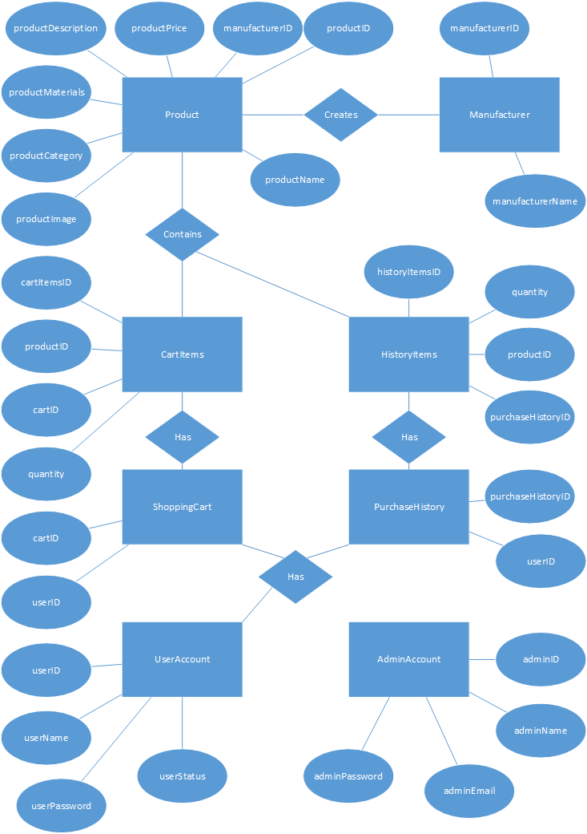

Database Normalisation Diagram

Data Dictionary

**Entity Types**

|  |  |  |  |
| --- | --- | --- | --- |
| *Entity Name* | *Description* | *Aliases* | *Occurrence* |
| UserAccount | A user created account for purchasing items | User, Customer | Each user has one account |
| AdminAccount | An administrative account for updating and managing the app | Admin | Each admin has one account |
| Product | An item for sale in the store | Item | One to many products may exist in the store |
| Manufacturer | Produce the items for sale |  | One manufacturer may have one to many items in the store |
| CartItems | Tracks the items in a user’s shopping cart |  | None to many cart items may exist in a shopping cart. One cart items contains one product and a quantity of said product |
| ShoppingCart | Shopping cart holding user’s items |  | User has one shopping cart |
| HistoryItems | Tracks the items in a user’s purchase history |  | None to many history items may exist in a purchase history. One history items contains one product and a quantity of said product |
| PurchaseHistory | User’s purchase history |  | One purchase history to a user |

**Relationship Types**

|  |  |  |  |  |
| --- | --- | --- | --- | --- |
| *Entity Name* | *Multiplicity* | *Relationship* | *Multiplicity* | *Entity Name* |
| UserAccount | 1..1 | Has | 1..1 | ShoppingCart |
| UserAccount | 1..1 | Has | 1..1 | PurchaseHistory |
| Manufacturer | 1..1 | Creates | 0..* | Product |
| CartItems | 1..1 | Contains | 1..1 | Product |
| HistoryItems | 1..1 | Contains | 1..1 | Product |

**Attributes**

|  |  |  |  |  |  |  |
| --- | --- | --- | --- | --- | --- | --- |
| *Entity Name* | *Attributes* | *Description* | *Data Type & Length* | *Nulls* | *Multi-Valued* | *Derived* |
| Product | productId | Unique ID for every product | int | N | N | N |
|  | productName | Product name | varchar(100) | N | N | N |
|  | productPrice | Product price | decimal(6, 2) | N | N | N |
|  | productMaterials | Materials of product | varchar(100) | N | N | N |
|  | productDescription | Brief blurb about product | varchar(1000) | N | N | N |
|  | productImage | URL of image related to product | varchar(150) | N | N | N |
|  | productCategory | Men’s or women’s | varchar(20) | N | N | Manufacturer |
|  | manufacturerID | ID of product manufacturer | int | N | N | N |
| Manufacturer | manufacturerID | ID of the manufacturer | int | N | N | N |
|  | manufacturerName | Name of the manufacturer | varchar(100) | N | N | N |
| ShoppingCArt | cartID | ID of shopping cart | int | N | N | N |
|  | userID | Associated user ID | int | N | N | UserAccount |
| UserAccount | userID | ID of user | int | N | N | N |
|  | userName | Username of user | varchar(50) | N | N | N |
|  | userPassword | Password of user | varchar(50) | N | N | N |
|  | accountStatus | Suspended or normal | bit | N | N | N |
| PurchaseHistory | purchaseHistoryID | ID of purchase history | int | N | N | N |
|  | userID | Associated user ID | int | N | N | UserAccount |
| CartItems | cartItemsID | ID of item in cart | int | N | N | N |
|  | productid | ID of associated product | int | N | N | Product |
|  | quantity | Quantity of product | int | N | N | N |
|  | cartID | ID of associated shopping cart | int | N | N | ShoppingCart |
| HistoryItems | historyItemsID | ID of item in history | int | N | N | N |
|  | productid | ID of associated product | int | N | N | Product |
|  | quantity | Quantity of product | int | N | N | N |
|  | purchaseHistoryID | ID of associated purchase history | int | N | N | PurchaseHistory |
| adminAccount | adminID | ID of admin account | int | N | N | N |
|  | adminName | Username of admin | varchar(50) | N | N | N |
|  | adminPassword | Password of admin | varchar(50) | N | N | N |
|  | adminEmail | Email address of admin | varchar(50) | N | N | N |